Systems of Linear Equations in Multiple Representations

INSTRUCTIONAL ACTIVITY SUPPLEMENT

Lesson 1

Group A

You are a member of the student council at your school and are planning a field trip for your class. You are considering two different options: Mike’s Mini-Golf and Izzy’s Ice Skating. After some research, you find that Mike’s Mini-Golf charges $10 per person for all you can putt mini-golf for three hours. Izzy’s Ice Skating charges $200 plus $5 per person for the same amount of time.

* Which option is the better choice based on cost?
* Is there a number of people for which the costs would be equal?
* Use any mathematics or representations that are useful to your decision making process.

Group B

You are a member of the student council at your school and are planning a field trip for your class. You are considering two different options: Mike’s Mini-Golf and Izzy’s Ice Skating. You see the following ads in the newspaper:

Izzy’s Ice Skating

Only $200 for 3 hours!*

*$200 flat rate plus $5 per person

Mike’s Mini-Golf

All you can putt for 3 hours!*

*$10 per person

* Which option is the better choice based on cost?
* Is there a number of people for which the costs would be equal?
* Use any mathematics or representations that are useful to your decision making process.

Group C

You are a member of the student council at your school and are planning a field trip for your class. You are considering two different options: Mike’s Mini-Golf and Izzy’s Ice Skating. The following table provides information regarding the total costs of each option based on the number of people.

|  |  |  |  |  |  |  |  |
| --- | --- | --- | --- | --- | --- | --- | --- |
| Number of Students | | | | | | | |
|  | 0 | 10 | 20 | 30 | 40 | 50 | 60 |
| Mike’s Mini-Golf | $0 | $100 |  |  |  |  | $600 |
| Izzy’s Ice Skating | $200 |  | $300 |  |  |  |  |

* Which option is the better choice based on cost?
* Is there a number of people for which the costs would be equal?
* Use any mathematics or representations that are useful to your decision making process.

Group D

You are a member of the student council at your school and are planning a field trip for your class. You are considering two different options: Mike’s Mini-Golf and Izzy’s Ice Skating. The following graph provides information regarding the total costs of each option based on the number of people.

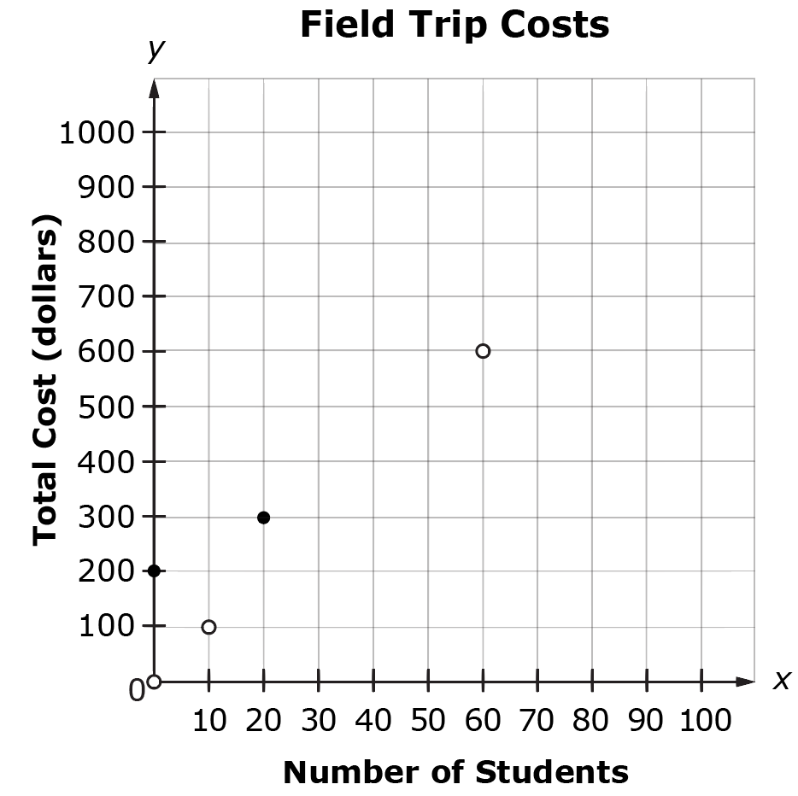

Izzy’s Ice Skating

Mike’s Mini-Golf

* Which option is the better choice based on cost?
* Is there a number of people for which the costs would be equal?
* Use any mathematics or representations that are useful to your decision making process.

Systems of Linear Equations in Multiple Representations

Lesson 2

1. You are buying flowers at the garden store when you see your neighbor buying flowers as well. You purchase three daffodils and one pansy for $11.00 total. Your neighbor purchases one daffodil and two pansies for $7.00 total.
   1. How much does each daffodil and each pansy cost? Show your reasoning.
   2. 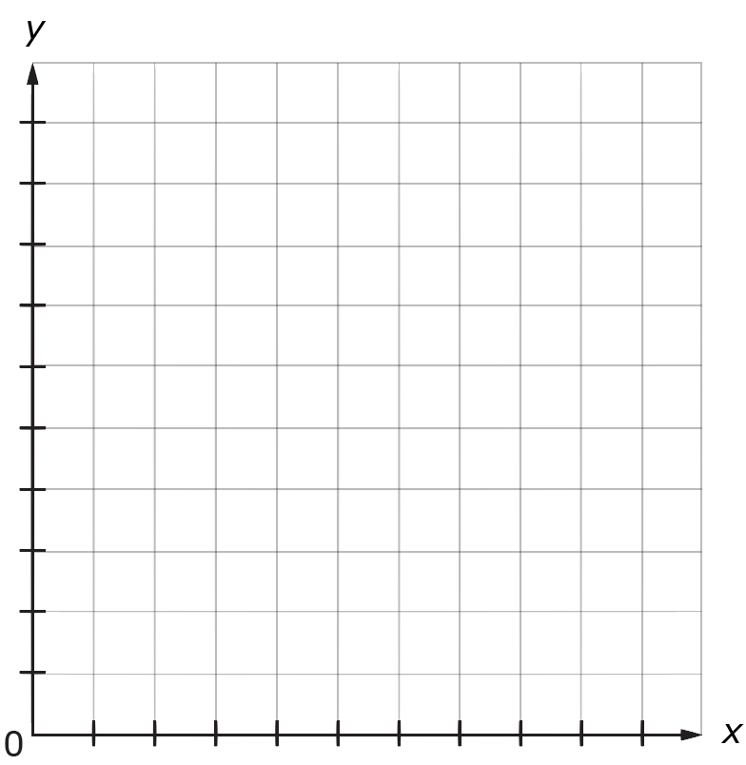Graph the scenario on the following coordinate plane. How does the solution appear on the graph?
2. Molly and James just got new jobs. Molly’s job pays $7 per shift plus $3 per item sold. James’s job pays $15 per shift plus $1 per item sold.
   1. How many items would Molly and James each have to sell in order to make the same amount of money in a shift? How much money would they make if they sold that number of items? Show your reasoning.
   2. Graph the scenario on the following coordinate plane. How does the solution appear on the graph?



Systems of Linear Equations in Multiple Representations

Lesson 3

For the following questions, plot the first pair of points and draw a line through the points, then plot the second pair of points and draw a line through the points. Use a straightedge to be as precise as possible as you connect each pair of points. Once the lines are graphed, determine (if necessary, estimate) the solution to the system of equations.

1. Line 1 goes through the points (–3, 8) and (–1, 0). Line 2 goes through the points (–2, 4) and (0, –4).
2. What is the solution to this system of equations?

1. How does the graph represent the solution?
2. Line 1 goes through the points (–4, 0) and (0, 3). Line 2 goes through the points (–6, 1.5) and (5, 1.5).
3. What is the solution to this system of equations?

1. How does the graph represent the solution?

1. Line 1 goes through the points (–7, –4) and (–1, 2). Line 2 goes through the points (–1, – $\frac{2}{3}$) and (3, 3 $\frac{1}{3}$).
2. What is the solution to this system of equations?

1. How does the graph represent the solution?

1. Line 1 goes through the points (2, 7) and (8, –3). Line 2 goes through the points (0, 0) and (10, –2).
2. What is the solution to this system of equations?

1. How does the graph represent the solution?

Systems of Linear Equations in Multiple Representations

INSTRUCTIONAL ACTIVITY SUPPLEMENT

Lesson 3

Cut out the following systems of equations and sort them based on whether they have one solution, no solution, or infinitely many solutions.

|  |  |  |
| --- | --- | --- |
| $$\left\{\begin{aligned}y=2x+1 \\ y=2x-1\end{aligned}\right.$$ | $$\left\{\begin{aligned}x+y=\frac{1}{2} \\ 4x+6y=3\end{aligned}\right.$$ | $$\left\{\begin{aligned}y=2x+7 \\ y=2x+7\end{aligned}\right.$$ |
| $$\left\{\begin{aligned}y=-x+1 \\ y=5x+19\end{aligned}\right.$$ | $$\left\{\begin{aligned}y=3x-1 \\ 3y=9x-3\end{aligned}\right.$$ | $$\left\{\begin{aligned}x+y=5 \\ x+y=7\end{aligned}\right.$$ |
| $$\left\{\begin{aligned}y=\frac{1}{2}x+1 \\ 2y=-\frac{1}{4}x+12\end{aligned}\right.$$ | $$\left\{\begin{aligned}2x+3y=6 \\ 4x+6y=11\end{aligned}\right.$$ | $$\left\{\begin{aligned}2x+y=10 \\ 4x+2y=20\end{aligned}\right.$$ |
| $$\left\{\begin{aligned}4y=x+8 \\ y=\frac{1}{4}x-5\end{aligned}\right.$$ | $$\left\{\begin{aligned}y-x=8 \\ 2y-2x=16\end{aligned}\right.$$ | $$\left\{\begin{aligned}y=x \\ 3x+2y=-20\end{aligned}\right.$$ |
| $$\left\{\begin{aligned}\frac{1}{2}y=\frac{1}{4}x+1 \\ 2y=x+4\end{aligned}\right.$$ | $$\left\{\begin{aligned}4x-3y=10 \\ 4x-3y=8\end{aligned}\right.$$ | $$\left\{\begin{aligned}6x-9y=-4 \\ 3x+3y=3\end{aligned}\right.$$ |
| $$\left\{\begin{aligned}5x-y=10 \\ x-\frac{1}{5}y=2\end{aligned}\right.$$ | $$\left\{\begin{aligned}4x+3y=5 \\ 2x-y=5\end{aligned}\right.$$ | $$\left\{\begin{aligned}y=-\frac{1}{2}x-3 \\ y=-\frac{1}{2}x-4\end{aligned}\right.$$ |

Systems of Linear Equations in Multiple Representations

Lessons 1 – 3

1. You have just moved to a new home and need to set up cable service. After calling two companies, TV Now and Cable Crew, you find out both companies charge to set up cable service, then charge monthly to use the service. Assuming the cost per month is constant for each company, complete and use the table to answer the following questions.

|  |  |  |
| --- | --- | --- |
| Total Amount Paid For Cable Service | | |
| **Month** | **TV Now** | **Cable Crew** |
| 0 | $100 | $70 |
| 1 | $165 | $138 |
| 2 | $230 | $206 |
| 3 |  |  |
| 4 |  |  |
| 5 |  |  |
| 6 |  |  |
| 7 |  |  |
| 8 |  |  |
| 9 |  |  |
| 10 |  |  |
| 11 |  |  |
| 12 |  |  |

* 1. Will the costs ever be the same for both companies? If yes, after how many months? How much would you have spent in total? If no, why not?

* 1. Which company should you get cable service from? Explain your reasoning.

1. Jack and Jill are saving money in their piggy banks. Jack currently has $1.50 in his piggy bank, and Jill currently has $1.80 in her piggy bank. If Jack adds $0.30 to his piggy bank every day and Jill adds $0.25 to her piggy bank every day, will Jack and Jill ever have the same amount of money in their piggy banks? If yes, after how many days? How much money will be in the piggy banks? If no, why not? Explain or show the mathematical reasoning you use.

1. Sam goes to the store to buy fishing equipment with his friend Joe. Sam buys three hooks and two bobbers and pays $3.20. Joe buys two hooks and one bobber and pays $1.85. How much does one hook cost? How much does one bobber cost? Explain or show the mathematical reasoning you use.

1. Alyssa and Alice are running on the track. Alyssa starts half a lap ahead of Alice. Alyssa runs half a lap every minute. Alice also runs half a lap every minute. Will Alyssa and Alice ever be at the same point on the track at the same time? If yes, after how many minutes? How many total laps will they have run? If no, why not? Explain or show the mathematical reasoning you use.

1. Bob buys painting supplies at the local hardware store. In his first trip to the store, he buys two gallons of paint and three paint rollers for $55.00. Bob runs out of paint and paint rollers, so he goes back to the same hardware store and buys four gallons of paint and six rollers for $110.00. How much does one gallon of paint cost? How much does one paint roller cost? Explain or show the mathematical reasoning you use.

1. Based on your observation of the patterns in the following systems of linear equations, determine whether there is one solution, no solution, or infinitely many solutions for each system of equations. Explain your reasoning for each problem. If there is one solution, determine the solution.






$\left\{\begin{aligned}2x-y=8 \\ 6x-3y=24\end{aligned}\right.$

$\left\{\begin{aligned}2y=8x-10 \\ y=2x+10\end{aligned}\right.$

$\left\{\begin{aligned}y=3x-3 \\ y=3x-6\end{aligned}\right.$

1. Plot each pair of coordinates and draw a line through each pair of points. Determine whether the system of linear equations has one solution, no solution, or infinitely many solutions. Explain how the number of solutions is related to the lines for each graph. If there is one solution, determine the solution.
   1. Line 1 goes through the points (0, 6) and (6, 0). Line 2 goes through the points (–1, 2) and (3, –2).
   2. Line 1 goes through the points (–8, –1) and (–2, 3). Line 2 goes through the points (1, 5) and (–5, 1).
   3. Line 1 goes through the points (0, 7) and (2, 3). Line 2 goes through the points (0, –2) and (4, –1).